**Selenium Testing Concepts**

1. **Image Comparison**
2. **Multi browser testing**
3. **Parallel browser testing**
4. **Tables in selenium**
5. **TestNG xml file to run multiple classes and get a single Report**

**Prerequisites:**

1. Maven projects with tests and scripts.

**Image Comparison:**

Step 1) Add selenium-shutterbug dependency to pom.xml file.

<https://mvnrepository.com/artifact/com.assertthat/selenium-shutterbug/0.9.3>

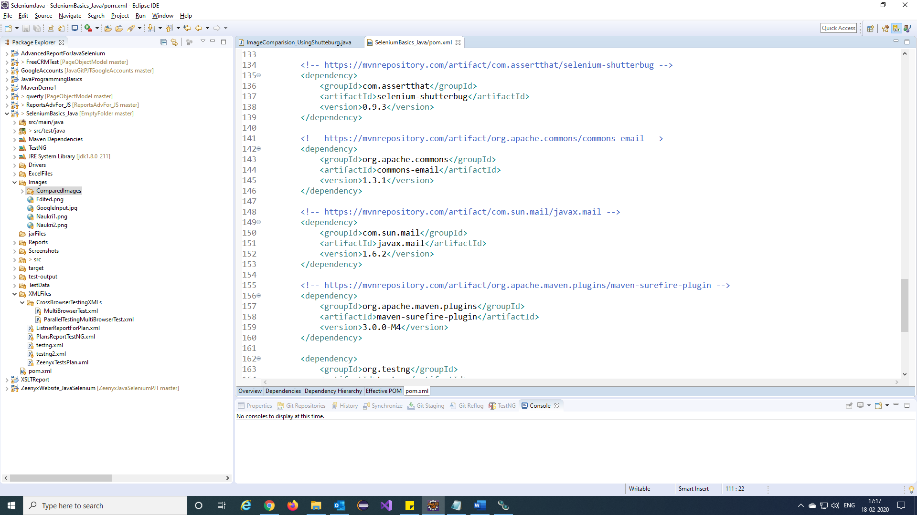

Step 2) Create a folder and put images to compare.

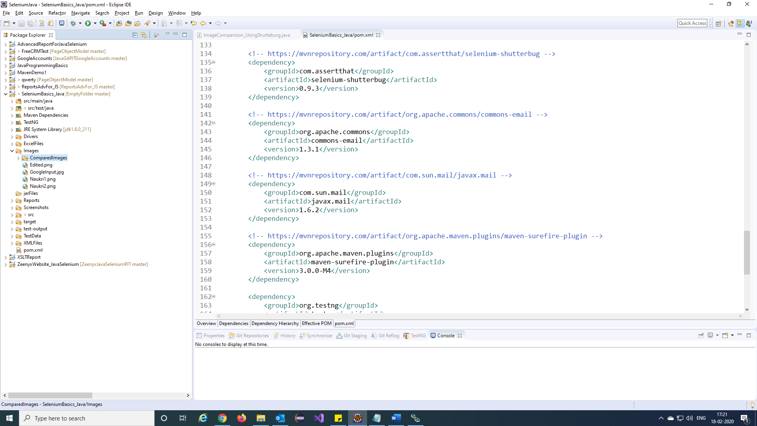

Step 3) Function to compare images.

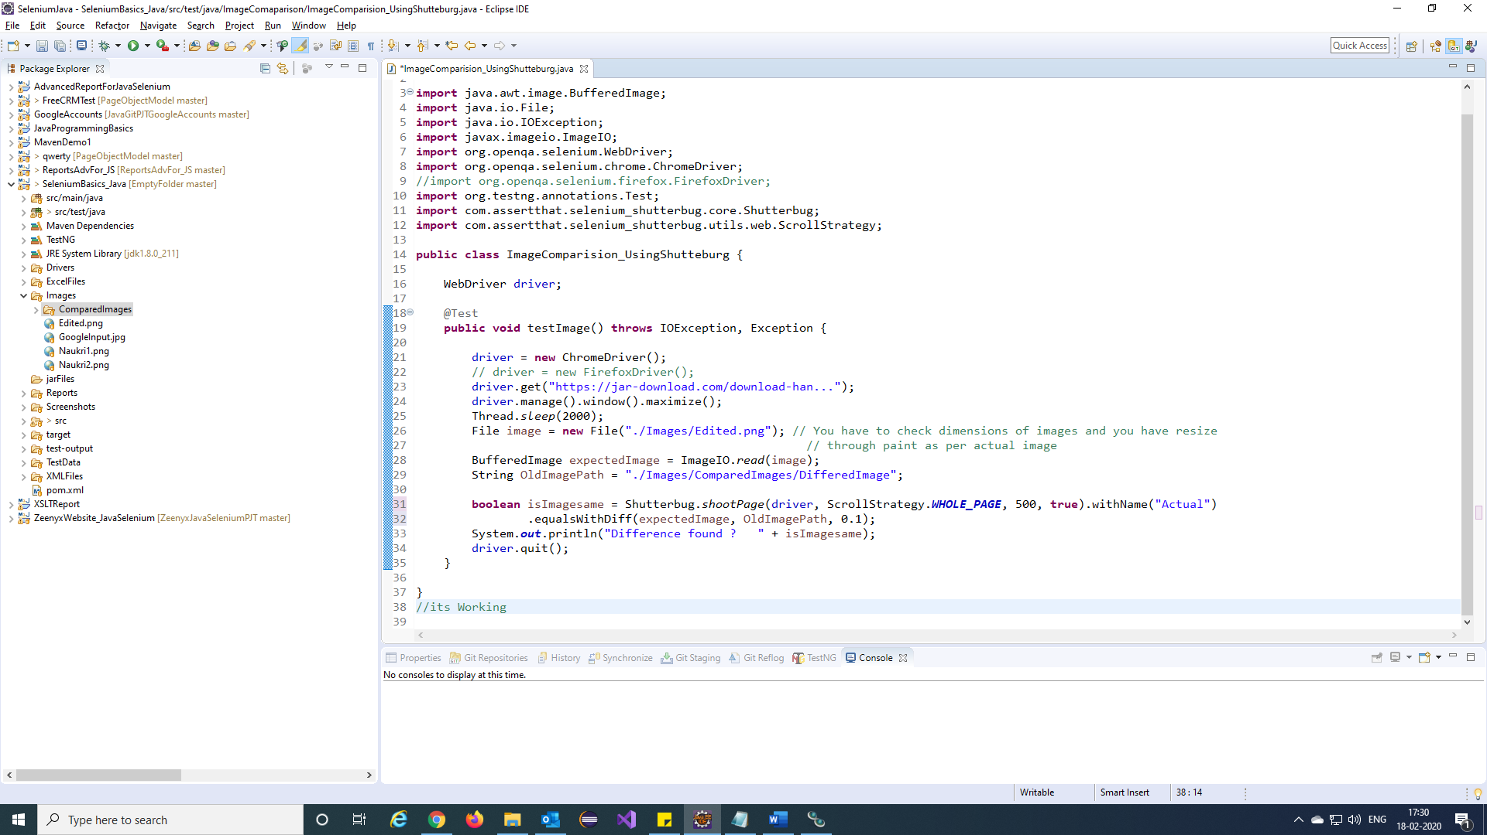

Step 4) We will get differed image like this.

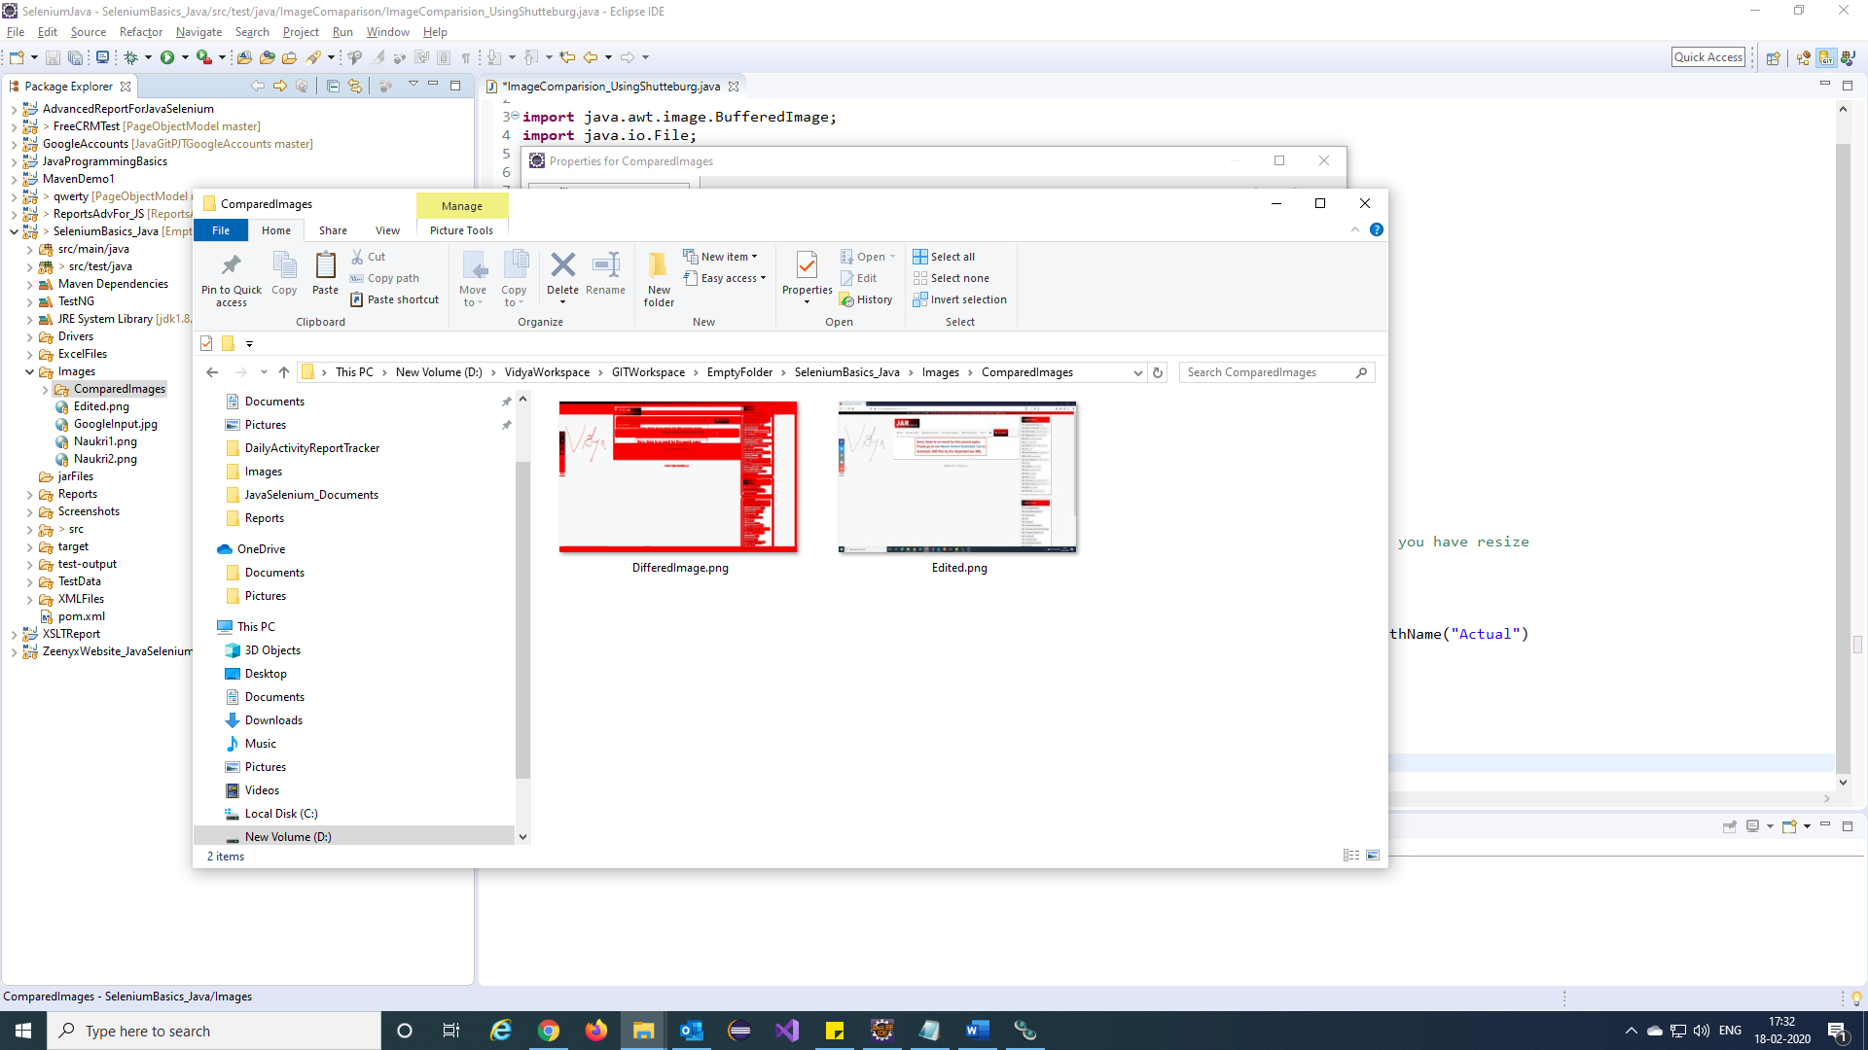

**Multi browser testing:**

Step 1) Write a function to run test in multi browsers.

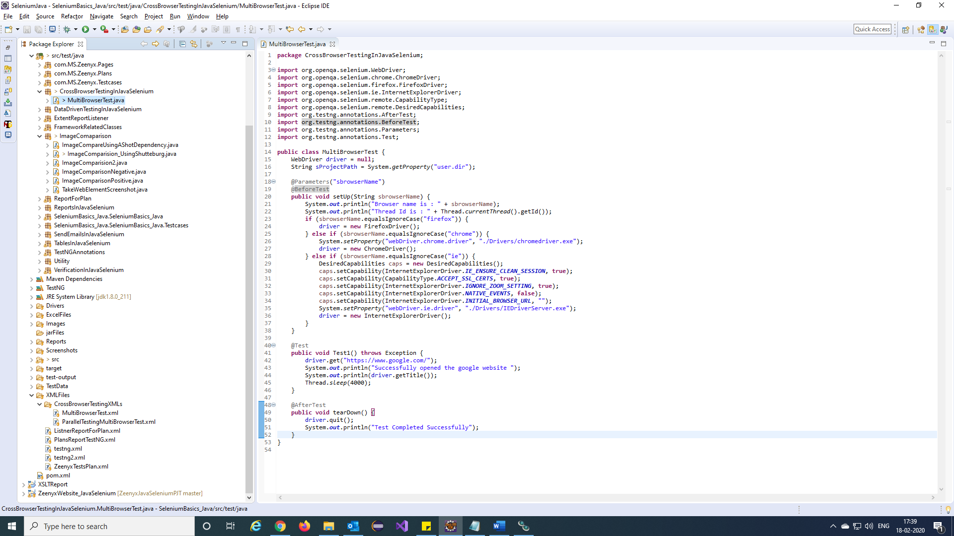

Step 2) Create TestNg xml file for your tests.

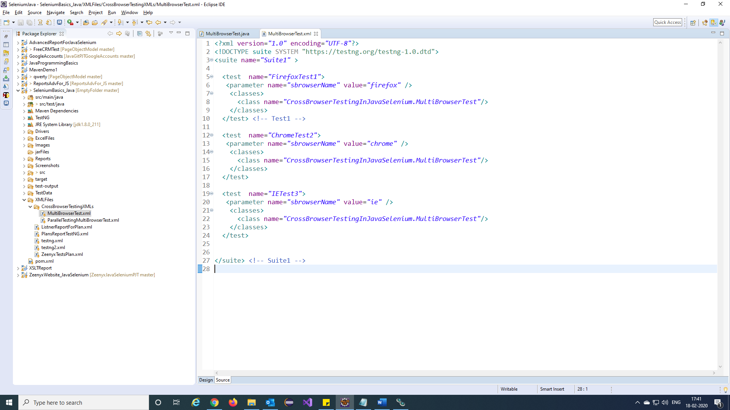

**Parallel browser testing:**

Step 1) Create TestNg xml file for above function.

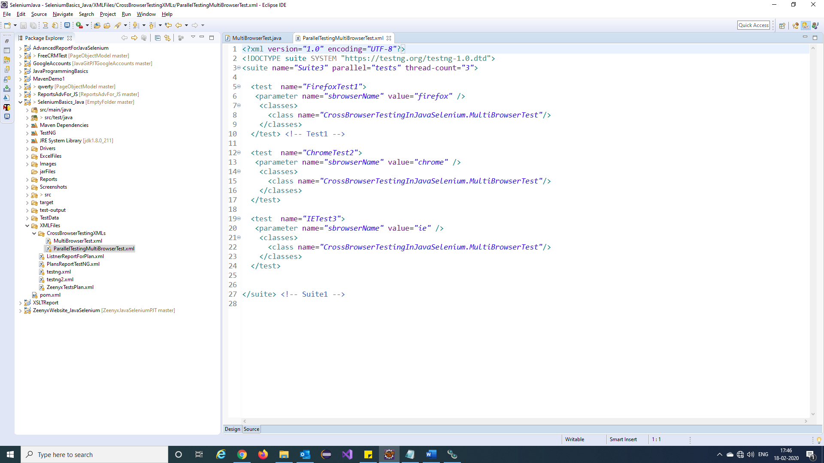

**Tables in selenium:**

Step 1) Fetch all values from table using this function in java selenium.

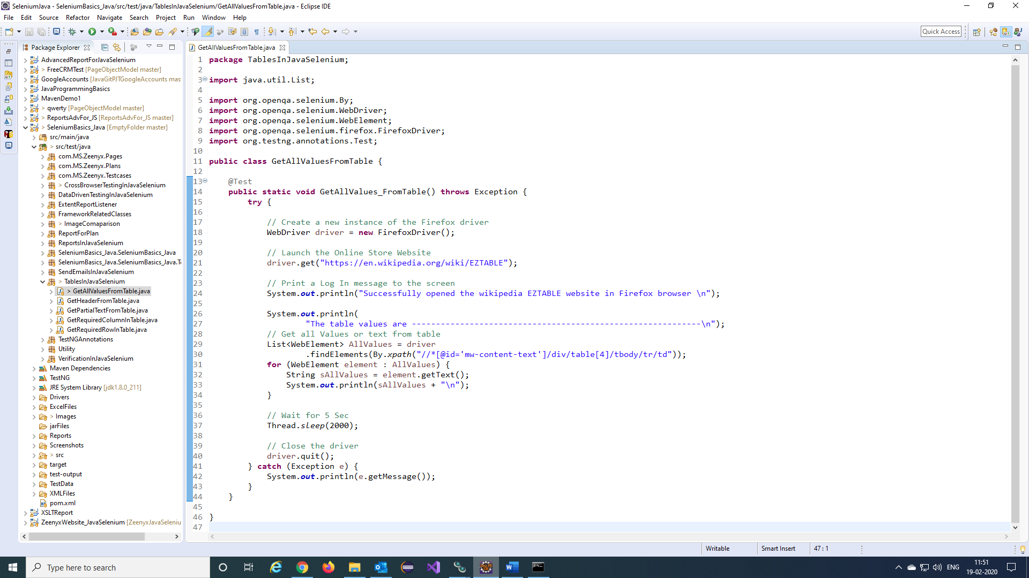

Step 2) Fetch Header values from table using this function in java selenium.

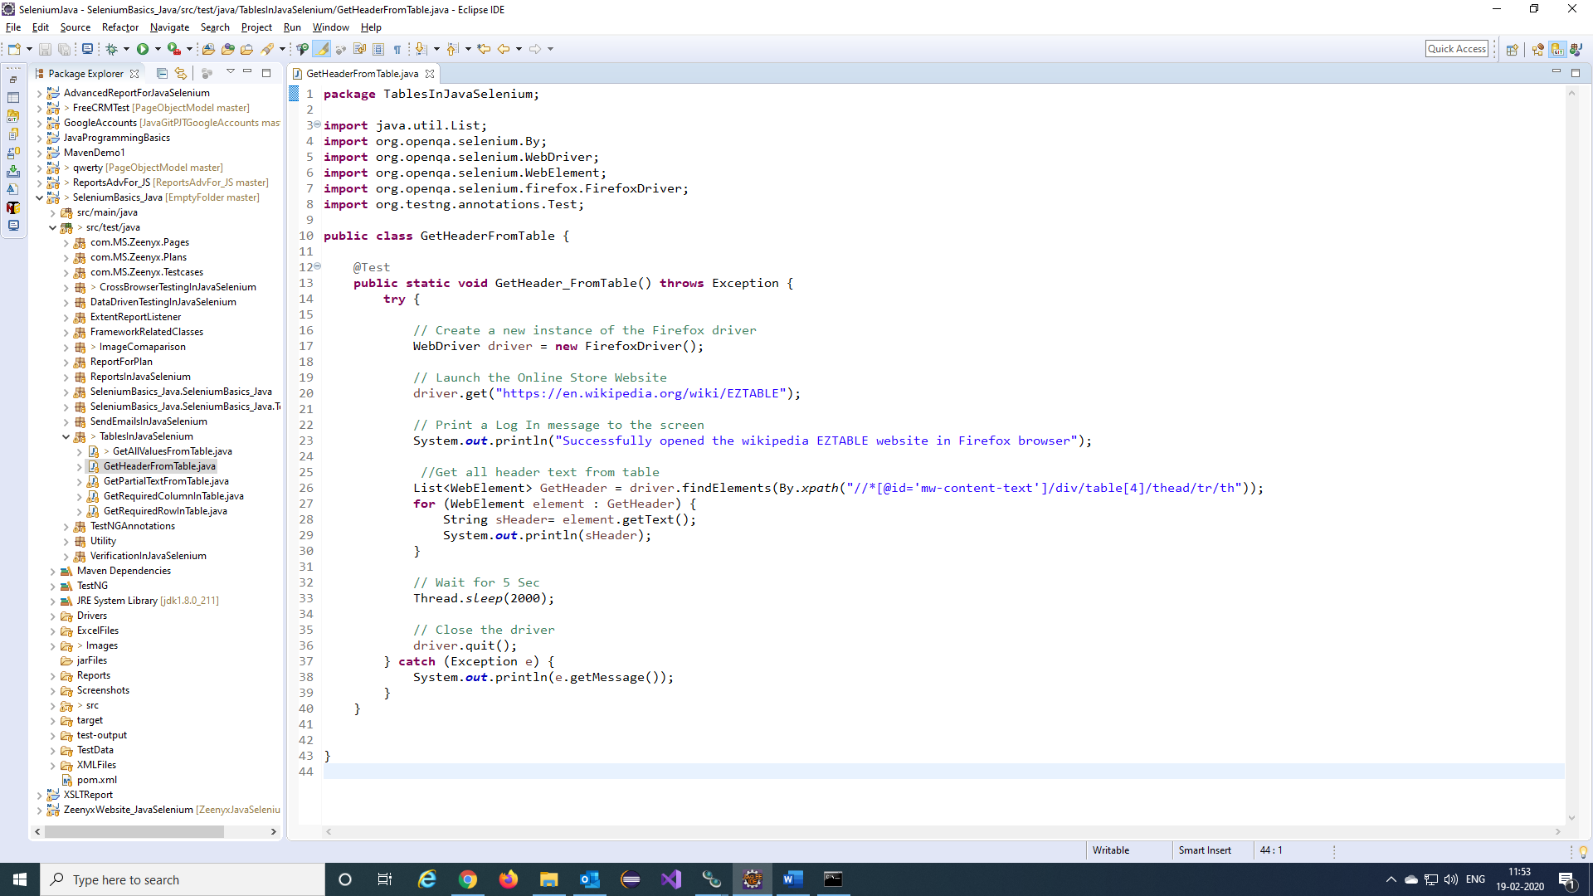

Step 3) Fetch required column values from table using this function in java selenium.

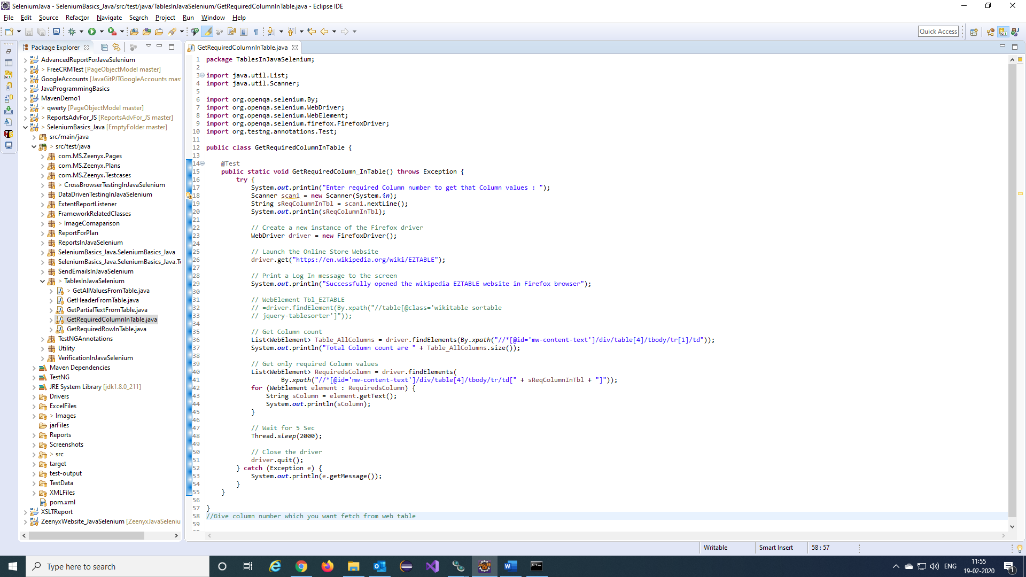

Step 4) Fetch required row values from table using this function in java selenium.

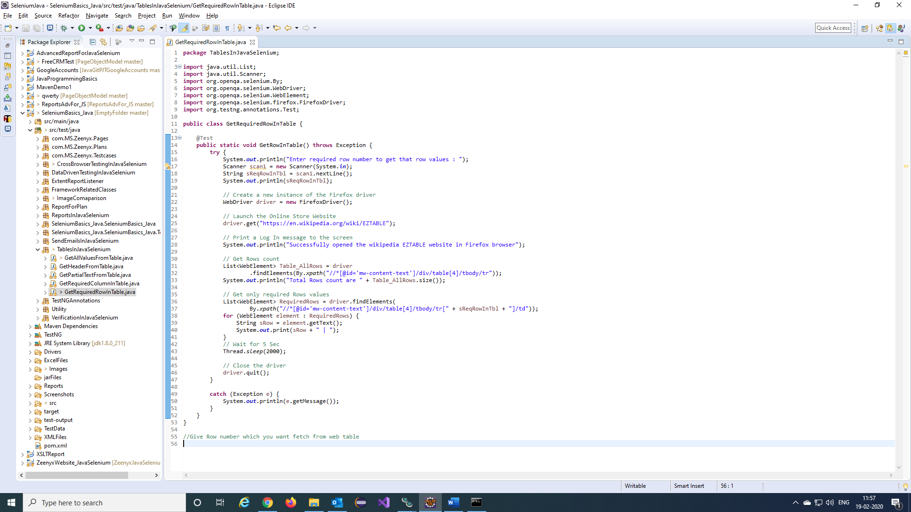

Step 5) Fetch Partial values from table using this function in java selenium.

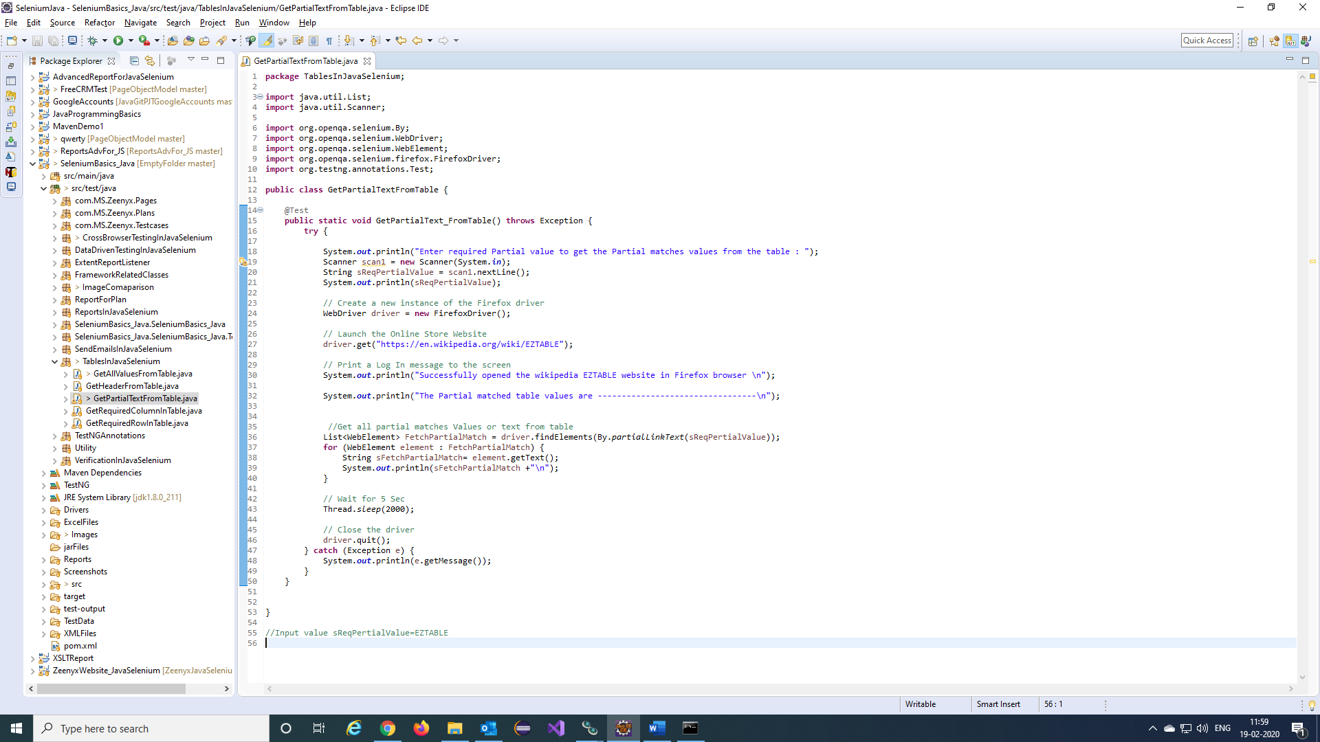

**TestNG xml file to run multiple classes and get a single Report:**

Step 1) Created a function for report.

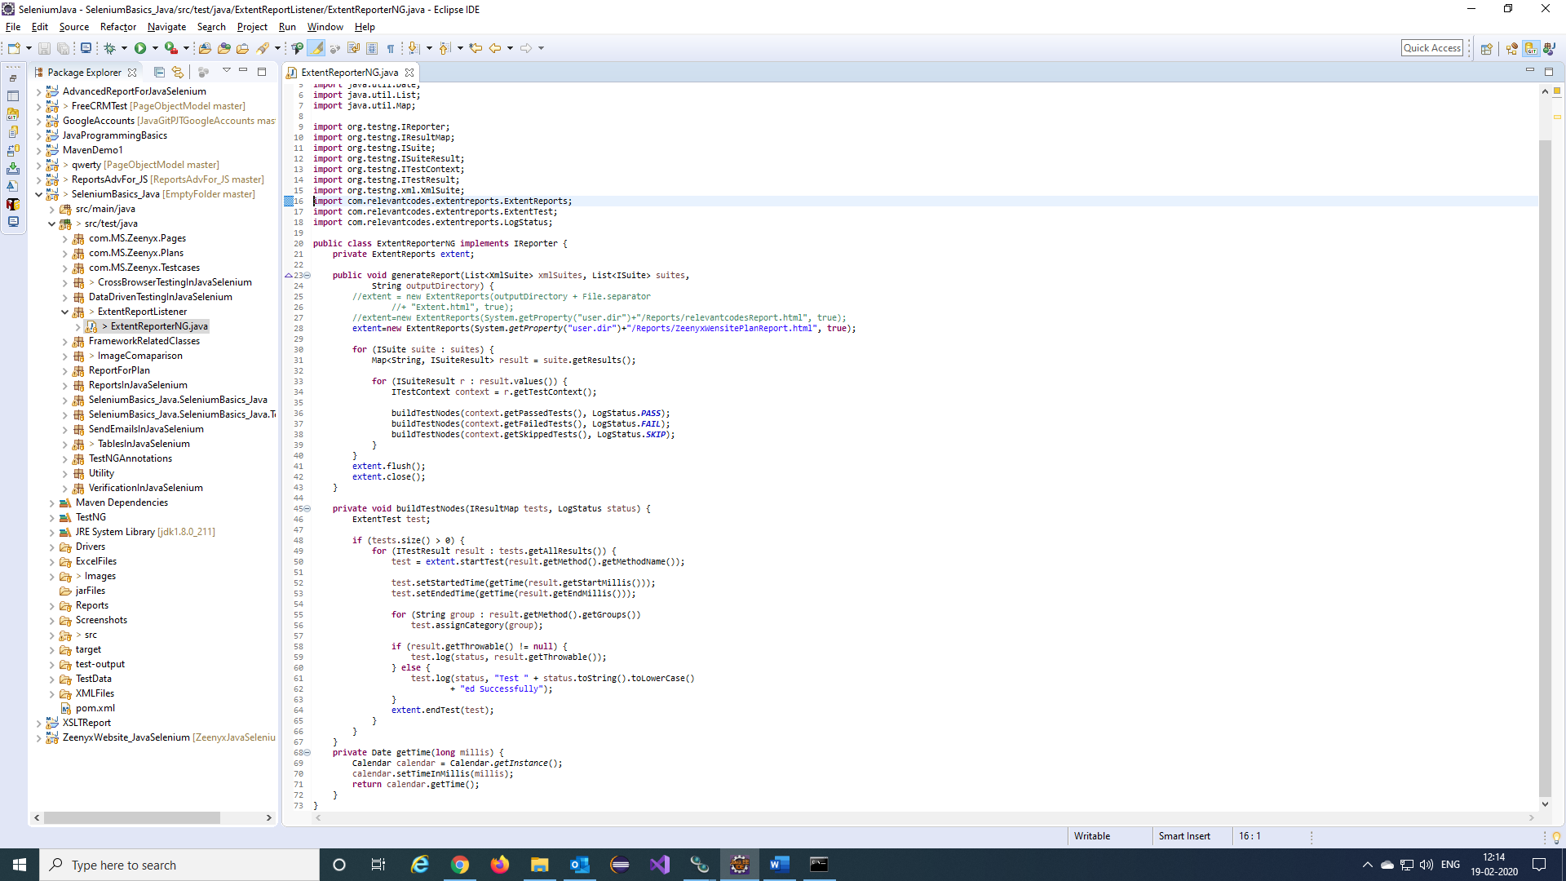

Note: Add relevantcodes dependency to pom.xml file.

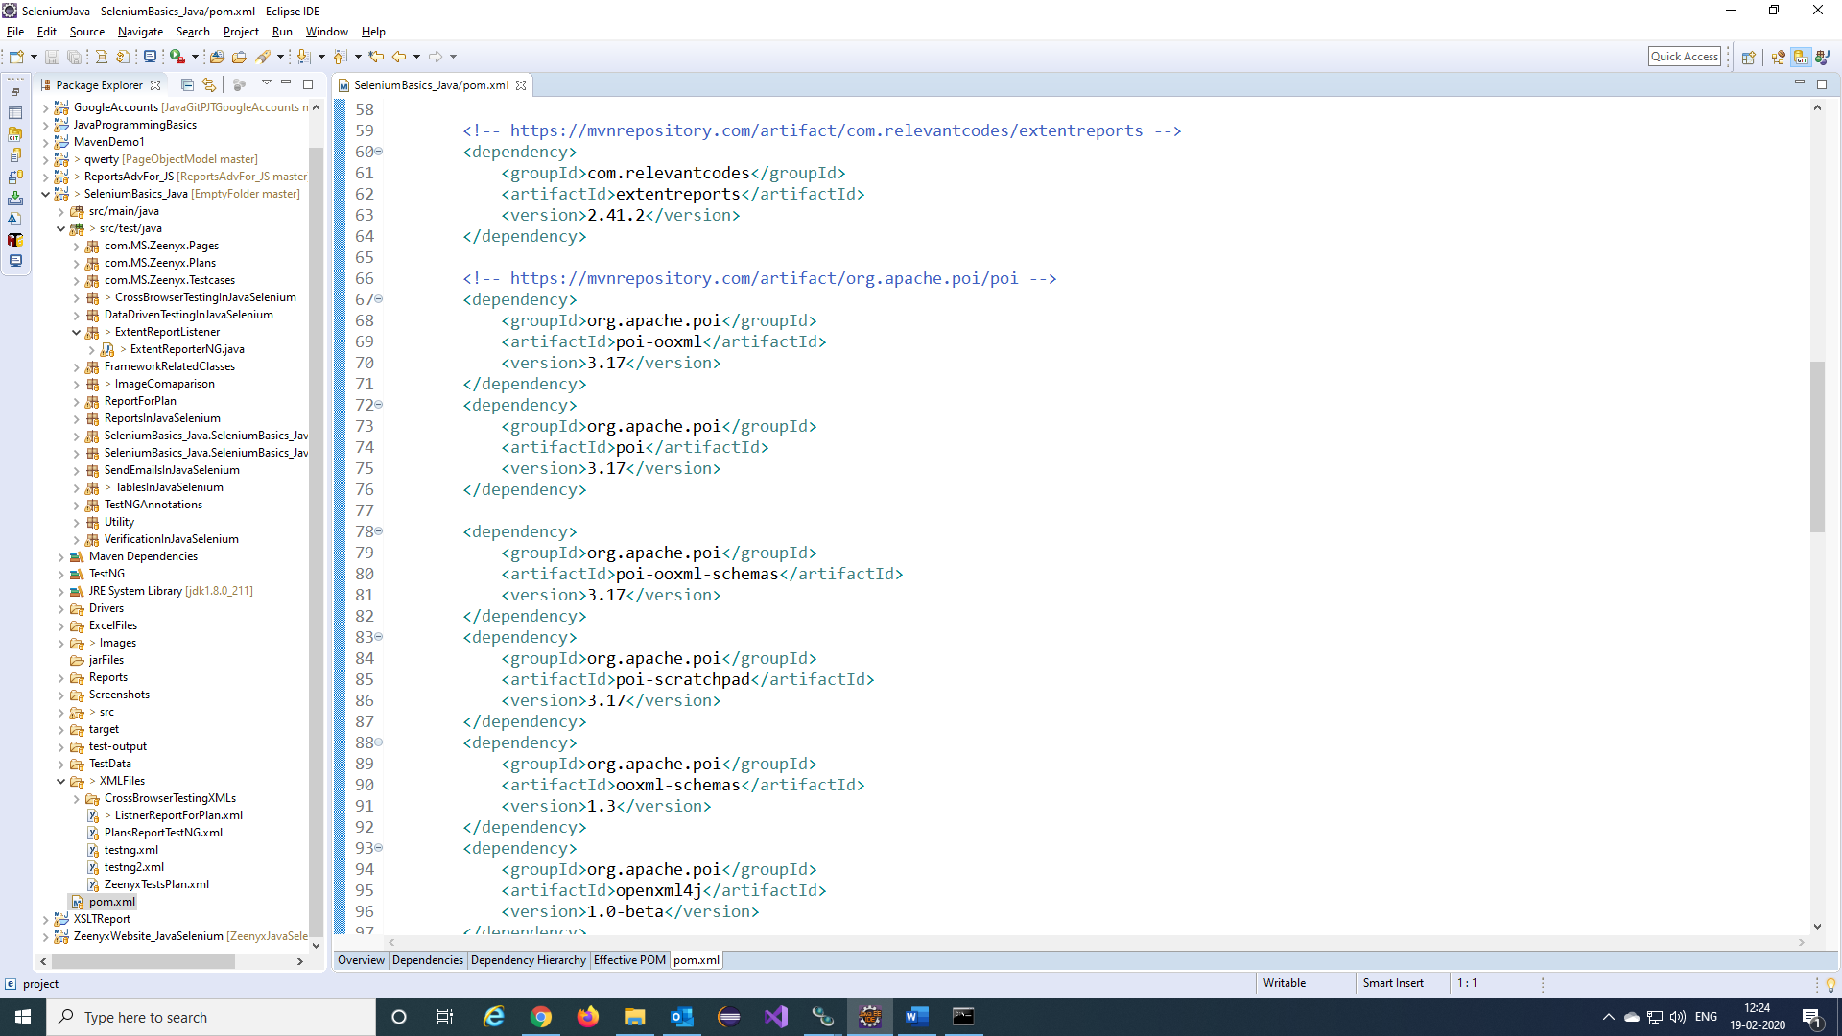

URL for dependency 🡪 <https://mvnrepository.com/artifact/com.relevantcodes/extentreports/2.41.2>

Step 2) Create a TestNg xml file for the testcases and add the report function as listener to TestNG xml file.

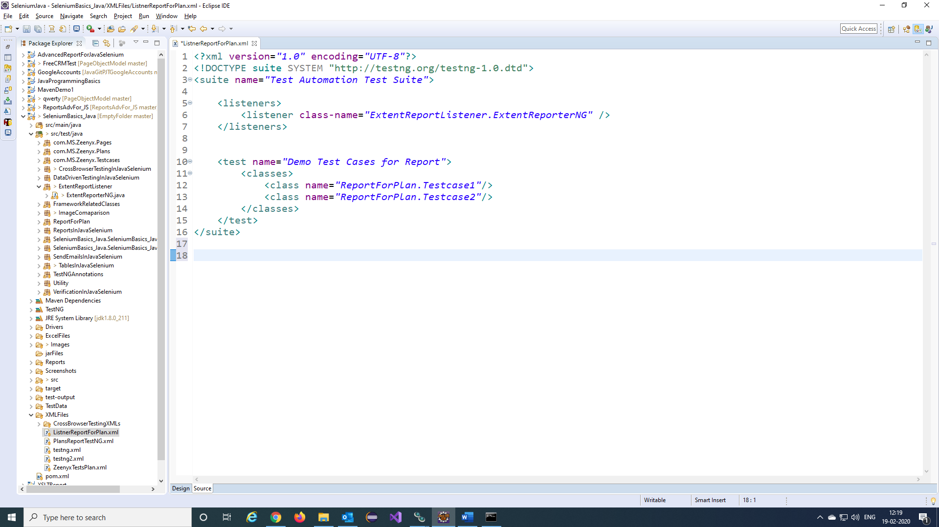

Step 3) We will get report like this.

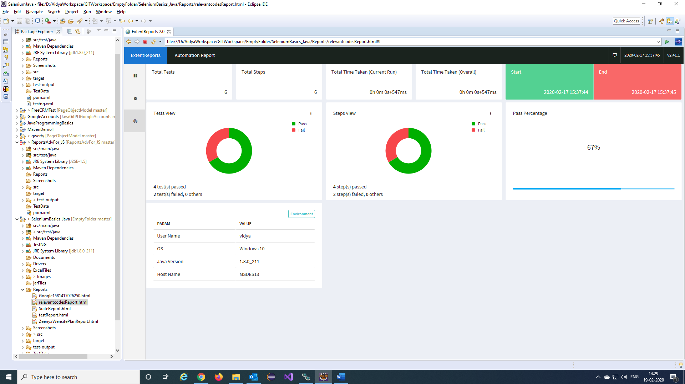

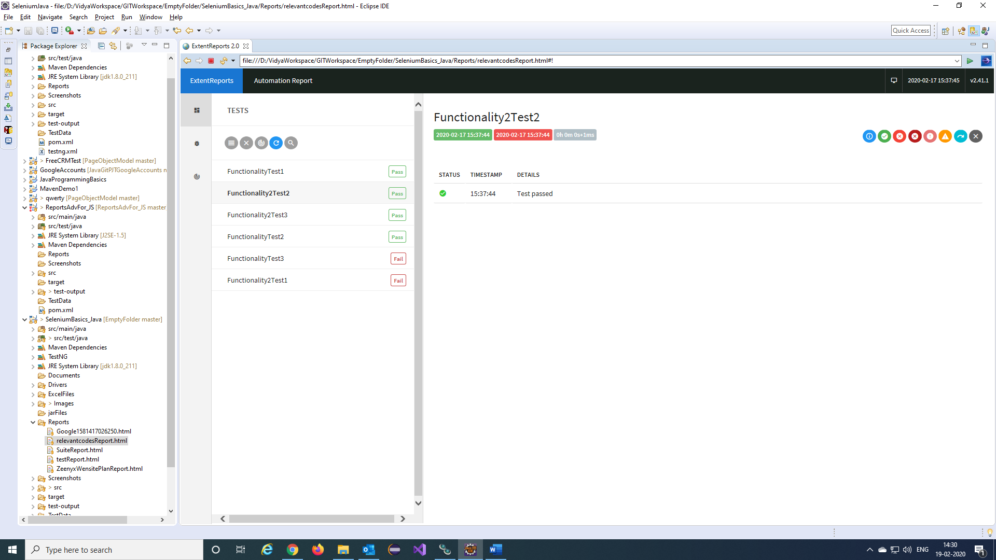

Step 4) The below snapshot shows error stack trace of failed steps.

